I. INTRODUCTION

Context of Free Movement Law
- Van Leeuwen sets the stage by describing the foundational structure of free movement law, which has been shaped by the Court of Justice of the European Union (CJEU).
- Traditional Framework:
  - Free movement law traditionally operates through four sequential analytical pillars:
    - Scope: Determining whether the situation falls within the scope of EU law, usually by establishing a cross-border element.
    - Direct Effect: Verifying whether the claimant can invoke free movement provisions against the measure or party at issue.
    - Restriction: Evaluating whether the national measure restricts free movement rights.
    - Justification: Examining whether the restriction can be justified under public interest grounds and, if so, whether it is proportionate.
  - This structure creates a step-by-step progression, ensuring clarity and predictability in decision-making.

Key Developments
- Van Leeuwen identifies significant shifts in the application of free movement law:
  - Blurring Boundaries Between Pillars:
    - The Court increasingly merges the distinct stages of analysis, particularly between:
      - Scope and restriction: Market access considerations sometimes determine whether a case falls within Article 34.
      - Restriction and justification: Justifications are often invoked without a clear analysis of whether a restriction exists.
  - Centralisation of Proportionality:
    - The proportionality test has become the dominant analytical tool, overtaking other stages of free movement law.
    - Proportionality serves as the ultimate balancing mechanism, assessing the legitimacy and necessity of national measures.
  - This shift has led to a more flexible but less predictable framework.

Problems with the Current Framework
- Legal Uncertainty:
  - The merging of pillars undermines the clarity of free movement law, making it harder for national courts, governments, and individuals to anticipate outcomes.
  - Example: Cases involving selling arrangements (Keck and Mithouard, Joined Cases C-267/91 and C-268/91) sometimes blur into market access analyses (Commission v Italy, Italian Trailers, Case C-110/05).
- ‘Backwards Reasoning’:
  - Van Leeuwen criticises the CJEU for engaging in reasoning that starts from the proportionality stage (justifications) and works backward to determine restriction or scope.
  - Example: In PreussenElektra (Case C-379/98), the Court justified a measure on environmental grounds without fully addressing whether a restriction existed.
- Doctrinal Fragmentation:
  - By focusing heavily on proportionality, the Court risks destabilising the structural coherence of free movement law.

The Role of Proportionality
- Evolution of Proportionality:
  - Historically, proportionality was applied at the justification stage to assess whether a restriction could be justified under public interest grounds.
  - Over time, proportionality has expanded into other stages, influencing the analysis of restriction and scope.
- Effet Utile:
  - The Court’s emphasis on proportionality reflects its commitment to the effet utile (effective application) of free movement law, ensuring that EU rights are not undermined by national measures.
  - However, Van Leeuwen warns that this centralisation has come at the expense of legal certainty and predictability.

Purpose and Structure of the Article
- Van Leeuwen’s central aim is to critically examine the impact of these developments on the structure of free movement law, particularly the consequences of proportionality’s centralisation.
- The article is divided into four main sections:
  - The Structure of Free Movement Law:
    - An analysis of the traditional framework and its doctrinal underpinnings.
  - Three Key Developments:
    - Exploration of how the interaction between pillars (scope, restriction, justification) has evolved.
  - Centralisation of Proportionality:
    - A detailed critique of proportionality’s dominant role in free movement cases.
  - Conclusion:
    - Recommendations for restoring clarity and coherence to free movement law.

Key Arguments
- Proportionality as a Double-Edged Sword:
  - While proportionality enables a flexible, context-sensitive approach to free movement disputes, its overuse undermines the structural integrity of free movement law.
- Judicial Activism and Centralisation:
  - The Court’s reliance on proportionality reflects its broader role in shaping the internal market but raises concerns about judicial overreach and erosion of Member State autonomy.
- Restoring Balance:
  - Van Leeuwen advocates for a return to the traditional step-by-step approach, ensuring that each pillar (scope, restriction, justification) is independently and consistently addressed.

Conclusion of the Introduction
- Van Leeuwen introduces the reader to a critical examination of the evolving structure of free movement law, focusing on the centralisation of proportionality and its impact on legal certainty and doctrinal coherence.
- The introduction sets the stage for the article’s broader argument: that the CJEU must strike a balance between the effective application of free movement law and the structural integrity of its analytical framework.

II. The Structure of Free Movement Law

Traditional Analytical Framework
Four-Step Structure:
Free movement law traditionally follows a clear, step-by-step process to determine whether a national measure violates EU free movement provisions. These steps are:
    - Scope: Determining whether the situation falls within the ambit of EU law (e.g., involving cross-border trade).
    - Direct Effect: Establishing whether the provision is directly effective and can be invoked by the claimant.
    - Restriction: Evaluating whether the national measure imposes a restriction on free movement rights.
    - Justification: Assessing whether the restriction is justified under public interest grounds and proportionate.
Purpose of the Framework:
  - This structure ensures logical reasoning and predictable outcomes by addressing each element in sequence.
  - It provides clarity for both national courts and Member States.

I. Scope
- Definition:
  - A measure falls within the scope of EU free movement law if it involves a cross-border element and affects intra-EU trade.
  - Article 34 TFEU applies only to measures that have an impact on trade between Member States.
- Key Case:
  - Geddo v Ente Nazionale Risi (Case 2/73): Defined quantitative restrictions as measures that “totally or partially restrain” imports, exports, or goods in transit.
- CJEU’s Flexible Approach:
  - The Court has adopted a broad interpretation of scope, often subsuming elements of restriction into the scope analysis.
  - Example:
    - Commission v Italy (Italian Trailers, Case C-110/05): The measure was included within Article 34’s scope because it had the potential to hinder market access for trailers, blending the scope and restriction stages.

II. Direct Effect
- Definition:
  - Direct effect enables individuals to invoke EU law provisions before national courts.
  - Free movement provisions are directly effective if they are clear, precise, and unconditional.
- Key Case:
  - Van Gend en Loos (Case 26/62): Established the principle of direct effect for Treaty provisions, including free movement.
- Horizontal Direct Effect:
  - Free movement provisions traditionally bind Member States, but the CJEU has extended their applicability to private parties in certain contexts.
  - Example:
    - Fra.bo SpA v Deutsche Vereinigung (Case C-171/11): A private certification body was held accountable under Article 34 for restricting the market access of an Italian manufacturer.
- Criticism:
  - The extension of horizontal direct effect merges this pillar with the analysis of restriction, as the Court justifies direct effect based on the existence of a restriction.

III. Restriction
Definition:
A national measure constitutes a restriction if it hinders or limits the exercise of free movement rights.
Evolution of Restriction Analysis:
1. Discrimination Test:
Early cases focused on discriminatory measures, either directly or indirectly targeting imported goods.
Example:
Dassonville (Case 8/74): Established the broad principle that all measures capable of hindering intra-EU trade, directly or indirectly, are considered restrictions.
2. Obstacles to Trade:
Later cases moved beyond discrimination, encompassing any measure that creates obstacles to the free movement of goods, even if non-discriminatory.
Example:
Cassis de Dijon (Case 120/78): Indistinctly applicable product requirements, such as minimum alcohol content rules, were held to restrict trade.
3. Market Access Test:
Recent jurisprudence focuses on whether a measure hinders market access for imported goods.
Example:
Mickelsson & Roos (Case C-142/05): Restrictions on jet ski use in Sweden were found to restrict market access, even though they applied equally to domestic and imported goods.

IV. Justification
- Role of Justifications:
  - National measures that restrict free movement can be justified if they pursue legitimate objectives and comply with the principle of proportionality.
  - Justifications fall into two categories:
    - Treaty-Based Justifications (Article 36 TFEU):
Includes public morality, public policy, public security, protection of health, etc.
Example:
Henn and Darby (Case 34/79): A UK ban on pornographic materials was justified on grounds of public morality.
    - Mandatory Requirements:
Introduced in Cassis de Dijon, mandatory requirements allow for additional justifications, such as consumer protection, environmental protection, and cultural preservation.
Example:
PreussenElektra (Case C-379/98): A German renewable energy policy was justified on environmental protection grounds, even though it discriminated against imports.

Challenges to the Four-Pillar Framework
- Doctrinal Blurring:
  - The CJEU often merges distinct stages, such as scope and restriction or restriction and justification.
  - Example:
    - In Italian Trailers, the scope analysis was based on the existence of a market restriction, effectively combining these two steps.
- Overemphasis on Proportionality:
  - Justifications and proportionality have become central to the Court’s reasoning, overshadowing the earlier pillars.
  - Example:
    - In Scotch Whisky Association v Lord Advocate (Case C-333/14), the Court focused heavily on proportionality to determine whether minimum alcohol pricing could be justified under public health grounds.
- Erosion of Legal Certainty:
  - By departing from a step-by-step approach, the CJEU has introduced unpredictability into free movement law, making it harder for Member States to design compliant measures.

Conclusion of Section II
- Van Leeuwen argues that the traditional four-pillar framework of free movement law provided clarity and predictability by addressing each stage independently.
- However, the CJEU’s tendency to merge these stages—particularly through the centralisation of proportionality—has led to doctrinal confusion and legal uncertainty.
- He calls for a return to a clearer structure that preserves the distinct analytical steps while balancing market integration with Member State autonomy.

III. Three Developments in Free Movement Law
This section explores how the Court of Justice of the European Union (CJEU) has reshaped free movement law through three key doctrinal developments:
- Market Access: Interaction Between Scope and Restriction
- Horizontal Direct Effect: Interaction Between Direct Effect and Restriction
- Assimilation of Justifications: Interaction Between Restriction and Justification

1. Market Access: Interaction Between Scope and Restriction

Traditional Distinction
- Traditionally, the scope of EU free movement law was determined by whether the measure affected intra-EU trade, while the restriction analysis assessed the substantive impact of the measure.
- Van Leeuwen argues that the market access test has blurred these stages, as measures are often deemed to fall within the scope of Article 34 TFEU because they restrict market access.

Keck and the Exclusion of Selling Arrangements
- In Keck and Mithouard (Joined Cases C-267/91 and C-268/91), the CJEU introduced the distinction between:
  - Product Requirements: Always subject to Article 34, as they create barriers to trade.
  - Selling Arrangements: Excluded from Article 34 if they are non-discriminatory in law and fact.
- This distinction aimed to limit the overreach of the Dassonville formula, which defined restrictions broadly as “all trading rules capable of hindering intra-EU trade.”

Market Access Test
The market access test, introduced in Commission v Italy (Italian Trailers, Case C-110/05), focuses on whether a measure hinders access to the market, regardless of its classification.
  - Facts:
    - Italy prohibited motorcycles from towing trailers, effectively excluding certain trailers from the market.
  - Judgment:
    - The CJEU found that the measure restricted market access, even though it was non-discriminatory.
  - Significance:
    - The test subsumes the scope analysis into the restriction analysis, as measures are included within Article 34 if they affect market access.

Critiques of the Market Access Test
- Expansion of Article 34’s Scope:
  - The market access test expands Article 34 to include non-discriminatory measures that might have only an indirect effect on trade.
  - Example: In Mickelsson & Roos (Case C-142/05), Swedish restrictions on jet ski use were deemed to hinder market access, even though they applied equally to domestic and imported goods.
- Blurring of Distinctions:
  - Measures traditionally excluded as selling arrangements under Keck are increasingly scrutinized under the market access test.
  - Example: In Ker-Optika v ÀNTSZ (Case C-108/09), restrictions on online sales were treated as market access barriers.

2. Horizontal Direct Effect: Interaction Between Direct Effect and Restriction

Traditional Role of Direct Effect
- Free movement provisions traditionally applied to Member States, not private parties.
- Van Gend en Loos (Case 26/62): Established direct effect for Treaty provisions, allowing individuals to invoke EU law against national measures.

Extension to Private Parties
- The CJEU extended the horizontal direct effect of free movement provisions to private entities engaged in market regulation.
  - Walrave and Koch (Case 36/74):
    - Applied free movement rules to non-state actors in the context of employment and sports regulation.
  - Angonese (Case C-281/98):
    - Required private employers to comply with free movement rules.

Fra.bo and Market Access
- In Fra.bo SpA v Deutsche Vereinigung (Case C-171/11), the Court applied Article 34 to a private certification body that withdrew approval for an Italian manufacturer.
  - Facts:
    - The certification body’s decision created a de facto barrier to market access for the manufacturer.
  - Judgment:
    - The Court held that Article 34 could apply to private entities whose actions hinder market access.
  - Significance:
    - The Court used the existence of a restriction to justify horizontal direct effect, merging these two analytical stages.

Critiques
- Doctrinal Ambiguity:
  - By merging direct effect with restriction, the Court fails to clearly define the boundaries of Article 34’s applicability.
- Judicial Overreach:
  - Critics argue that extending horizontal direct effect undermines the traditional division of responsibilities between the EU and Member States.

3. Assimilation of Justifications: Interaction Between Restriction and Justification

Traditional Role of Justifications
- Restrictions on free movement can be justified under:
  - Article 36 TFEU: Treaty-based justifications, such as public morality, public security, and public health.
  - Mandatory Requirements: Non-Treaty justifications introduced in Cassis de Dijon (Case 120/78), such as consumer protection and environmental protection.

Integration of Restriction and Justification
- Van Leeuwen argues that the CJEU increasingly skips the formal restriction analysis, moving directly to the justification stage.
- PreussenElektra (Case C-379/98):
  - A German renewable energy policy was justified on environmental grounds, despite being directly discriminatory.
  - The Court avoided a detailed restriction analysis, instead focusing on proportionality.

Proportionality and Justification
- Proportionality has become the dominant tool for resolving free movement cases, often overshadowing the restriction analysis.
- Scotch Whisky Association v Lord Advocate (Case C-333/14):
  - Minimum alcohol pricing was upheld as proportionate to public health objectives, even though it hindered market access for imports.

Critiques
- Erosion of the Restriction Analysis:
  - By focusing on justifications, the Court dilutes the distinct analytical role of restriction.
- Flexibility vs. Legal Certainty:
  - Proportionality provides flexibility but undermines predictability, as national measures are assessed on a case-by-case basis.

Conclusion of Section III
- Van Leeuwen identifies three key developments in free movement law that have reshaped the traditional framework:
  - The market access test has blurred the line between scope and restriction, expanding Article 34’s reach.
  - The extension of horizontal direct effect to private parties merges direct effect and restriction analyses.
  - The assimilation of justifications into the restriction analysis centralizes proportionality, overshadowing the distinction between these stages.
- These developments have increased the flexibility of free movement law but at the cost of doctrinal clarity and legal certainty.

IV. The Centralisation of Proportionality in the Internal Market
This section explores how the proportionality principle has become central to the CJEU’s interpretation and application of free movement law, replacing the traditional structure of separate pillars. Van Leeuwen discusses this centralisation’s impact on the effet utile of free movement provisions and its broader consequences for legal certainty, Member State autonomy, and the coherence of EU law.

1. The Centralisation of Proportionality and the Effet Utile of Free Movement Provisions

Proportionality’s Role in Free Movement Law
- Proportionality is a judicial tool used to balance conflicting interests, such as the need for free movement and the pursuit of legitimate public interest objectives.
- Traditionally, proportionality was confined to the justification stage to assess whether a restriction on free movement could be justified under Article 36 TFEU or mandatory requirements (e.g., consumer or environmental protection).

Expansion of Proportionality
- Van Leeuwen argues that proportionality has increasingly infiltrated all stages of free movement law, from scope to restriction and justification.
- This centralisation reflects the CJEU’s commitment to ensuring the effet utile (practical effectiveness) of free movement provisions by prioritising economic integration.

Case Analysis: Proportionality in Action
- Schmidberger v Austria (Case C-112/00):
  - Facts: Austria allowed a roadblock protest that disrupted goods transport between Germany and Italy.
  - Judgment: The CJEU upheld Austria’s actions, finding that the right to freedom of expression outweighed the temporary restriction on free movement.
  - Proportionality Test:
    - The Court assessed whether Austria’s measure was necessary and proportionate to its objective of protecting fundamental rights.
  - Significance:
    - Proportionality served as the central tool for balancing competing rights (free movement vs. freedom of expression).
- Omega Spielhallen v Bonn (Case C-36/02):
  - Facts: A German ban on "laser tag" games was challenged under free movement law.
  - Judgment: The Court upheld the ban as proportionate, finding it necessary to protect human dignity.
  - Significance:
    - Proportionality was used to prioritise a Member State’s core constitutional value over economic freedoms.
- Scotch Whisky Association v Lord Advocate (Case C-333/14):
  - Facts: Scotland introduced minimum alcohol pricing, which disproportionately affected imported products.
  - Judgment: The measure was justified under public health grounds, subject to a proportionality assessment.
  - Key Principle:
    - The Court focused on proportionality rather than strict adherence to the discrimination or restriction tests.

Effet Utile and Flexibility
- The centralisation of proportionality enhances the effet utile of free movement provisions by enabling the Court to:
  - Adapt to complex cases involving multiple interests (e.g., fundamental rights, public health).
  - Balance economic integration with non-economic values, such as social and environmental objectives.

Criticism of Centralisation
- Judicial Overreach:
  - Van Leeuwen argues that proportionality’s dominance reflects the CJEU’s expansive role in shaping the internal market, encroaching on Member State autonomy.
  - Critics, including Weatherill, suggest that the Court’s reliance on proportionality risks transforming it into an "all-purpose tool" that undermines legal certainty.
- Erosion of Pillar Distinctions:
The use of proportionality at every stage (scope, restriction, justification) dilutes the traditional four-pillar framework, reducing doctrinal coherence.

1. Proportionality at the Restriction Stage

Purpose
- At the restriction stage, the proportionality principle is used to identify whether a national measure constitutes a restriction on free movement rights under EU law.
- The focus is on whether the measure creates an obstacle to intra-EU trade, regardless of its intention.

Scope
- Proportionality here addresses the effect of the measure, asking:
  - Does the measure restrict access to the market for goods from other Member States?
  - Is the measure non-discriminatory in law and fact?
- Example: The market access test (as seen in Commission v Italy, Italian Trailers, Case C-110/05) uses proportionality to determine if a measure hinders access to a Member State’s market.

Key Characteristics
- Objective Test:
  - The proportionality analysis is objective, focusing purely on the economic and functional impact of the measure on market access.
  - It does not consider whether the measure pursues legitimate public interest objectives.
- No Balancing:
  - The analysis does not balance the restriction against public interest justifications. Instead, it solely determines whether the measure constitutes a restriction.

Case Examples
- Mickelsson & Roos (Case C-142/05):
  - Swedish restrictions on jet ski use were assessed at the restriction stage using proportionality. The Court asked whether these restrictions made it harder for goods to access the market, even though they applied equally to domestic and imported goods.
- Keck and Mithouard (Joined Cases C-267/91 and C-268/91):
  - Proportionality was used to exclude certain non-discriminatory selling arrangements from the scope of Article 34 if they did not disproportionately affect imported goods.

2. Proportionality at the Justification Stage

Purpose
- At the justification stage, proportionality is used to evaluate whether a restriction can be justified under public interest grounds (e.g., public health, consumer protection) as per Article 36 TFEU or mandatory requirements (Cassis de Dijon).
- The focus is on balancing the restriction against the legitimate aim pursued by the measure.

Scope
- Proportionality here addresses the legitimacy and necessity of the measure, asking:
  - Is the measure suitable to achieve the stated public interest objective?
  - Is the measure necessary, or are there less restrictive alternatives available?
  - Does the measure strike a fair balance between its objectives and the burden on free movement?

Key Characteristics
- Balancing Test:
  - The proportionality analysis at this stage is subjective, involving a balancing exercise between the Member State’s interests and the rights protected under free movement law.
- Focus on Justifications:
  - The measure is assessed in light of the legitimacy of its aim (e.g., protecting public health) and its effectiveness in achieving that aim.

Case Examples
- Schmidberger v Austria (Case C-112/00):
  - Austria’s decision to allow a roadblock protest was justified on the grounds of freedom of expression. The proportionality test balanced the disruption to free movement against the fundamental rights of protesters.
- Scotch Whisky Association v Lord Advocate (Case C-333/14):
  - Scotland’s minimum alcohol pricing was upheld as proportionate at the justification stage because it pursued the legitimate aim of protecting public health, even though it disproportionately affected imported goods.
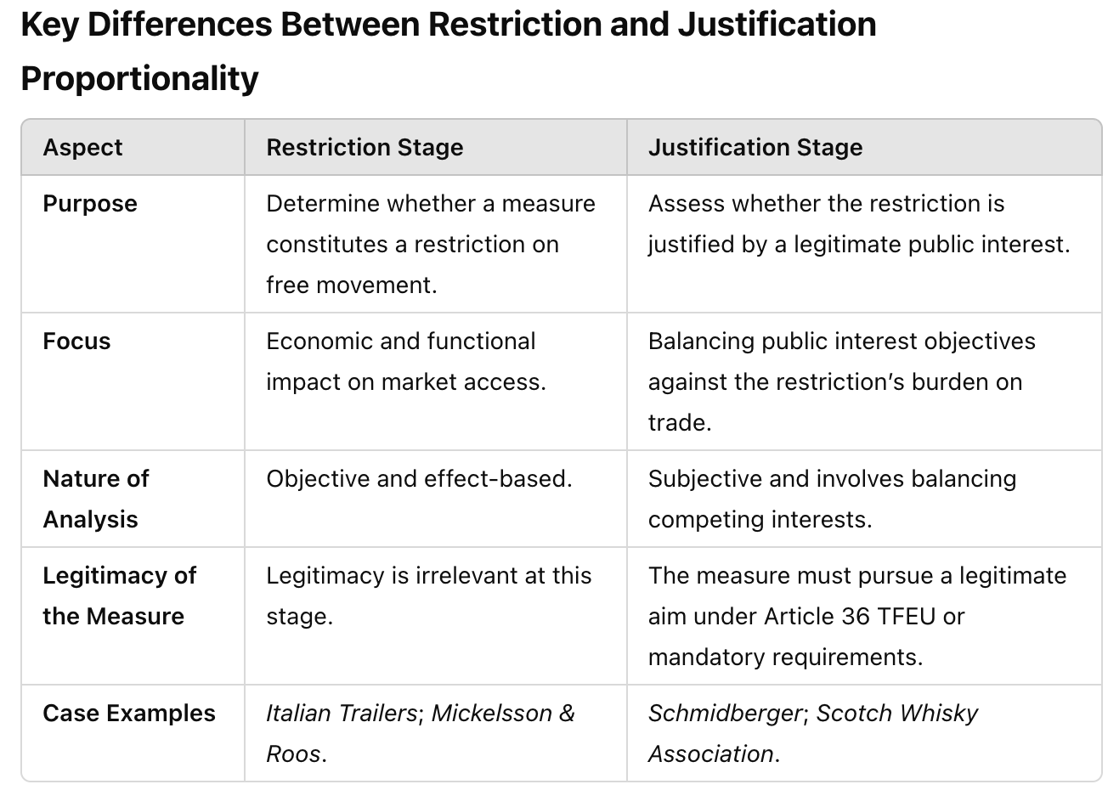

Critique of Proportionality in Both Stages
- At the Restriction Stage:
  - Expansive Reach:
    - The use of proportionality to define restrictions can broaden the scope of Article 34 TFEU, including measures that have minimal or indirect effects on trade (Dassonville, Italian Trailers).
  - Blurred Boundaries:
    - The market access test often merges the restriction and justification stages, creating doctrinal ambiguity.
- At the Justification Stage:
  - Judicial Overreach:
    - Critics argue that the CJEU’s reliance on proportionality at the justification stage gives it excessive discretion to second-guess national policy choices.
  - Uncertainty:
    - The subjective nature of proportionality balancing leads to inconsistent outcomes, as seen in cases like Schmidberger and Omega.
The key difference between proportionality at the restriction stage and the justification stage lies in its purpose and focus:
- At the restriction stage, proportionality evaluates whether a measure creates a barrier to market access.
- At the justification stage, proportionality balances the restriction against legitimate public interest objectives.

3. Proportionality at the Scope Stage

Purpose
Proportionality at the scope stage determines whether a national measure falls within the ambit of EU free movement law, particularly whether it involves a cross-border element and affects intra-EU trade.
Unlike the restriction or justification stages, proportionality at this stage is not fully developed or systematic, as the primary focus is on defining the measure’s applicability under Article 34 TFEU.

Scope in Free Movement Law

Traditional Approach
- Historically, the scope stage merely required the existence of a cross-border element (as per Van Gend en Loos, Case 26/62) or an effect on intra-EU trade (Dassonville, Case 8/74).
- Measures purely internal to one Member State or without significant trade effects were excluded.

Shift Toward Proportionality
Over time, the CJEU has incorporated proportionality-like reasoning into the scope stage by evaluating the significance of the measure’s impact on trade:
Measures with "too uncertain or indirect" effects are excluded from the scope of Article 34 (Krantz GmbH, Case C-69/88).

Proportionality in the Scope Stage

Emergence of Proportionality
The scope stage now involves assessing whether the measure disproportionately affects cross-border trade:
If the effect on trade is deemed insignificant, the measure falls outside Article 34.
However, the threshold for what constitutes a significant effect remains unclear, leaving room for proportionality to play a role.

Key Cases
- Krantz GmbH v Netherlands (Case C-69/88):
  - Facts:
    - Dutch authorities seized goods as part of a debt recovery process. The claimant argued this restricted free movement of goods.
  - Judgment:
    - The Court held that the effect on intra-EU trade was "too uncertain and indirect" to fall within the scope of Article 34.
  - Proportionality-Like Reasoning:
    - The Court effectively weighed the trade impact against the measure’s primary function, excluding it from Article 34.
- Commission v Italy (Italian Trailers, Case C-110/05):
  - Facts:
    - Italy prohibited motorcycles from towing trailers, which affected the market for imported trailers.
  - Judgment:
    - The Court included the measure within Article 34, finding that it significantly restricted market access.
  - Proportionality’s Role:
    - The Court assessed the measure’s practical effect on trade at the scope stage, blending the scope and restriction analyses.

Key Characteristics of Proportionality in Scope
- Threshold for Inclusion:
  - Proportionality at the scope stage involves determining whether the trade effect is sufficient to trigger Article 34.
  - If the measure’s impact is negligible or indirect, it is excluded.
- Economic Effects:
  - The Court evaluates the economic impact of the measure, considering whether it creates a real or potential barrier to trade.
- Blurring of Stages:
  - Van Leeuwen criticises the CJEU for merging the scope and restriction stages by relying on proportionality-like reasoning early in the analysis.

Critiques of Proportionality at the Scope Stage

1. Legal Uncertainty
- The lack of clear criteria for determining what constitutes a "significant effect" on trade creates uncertainty.
- Critics, including Van Leeuwen, argue that the flexible approach at the scope stage undermines the predictability of free movement law.

2. Over-Inclusion
- By incorporating proportionality into the scope stage, the Court risks over-including measures that have minimal trade effects, broadening Article 34’s reach.
- Example: In Mickelsson & Roos (Case C-142/05), Swedish jet ski restrictions were included in Article 34 because they indirectly limited market access, even though they applied equally to domestic and imported goods.

3. Blurred Boundaries
- The proportionality analysis at the scope stage often overlaps with the restriction stage, making it difficult to distinguish between the two.

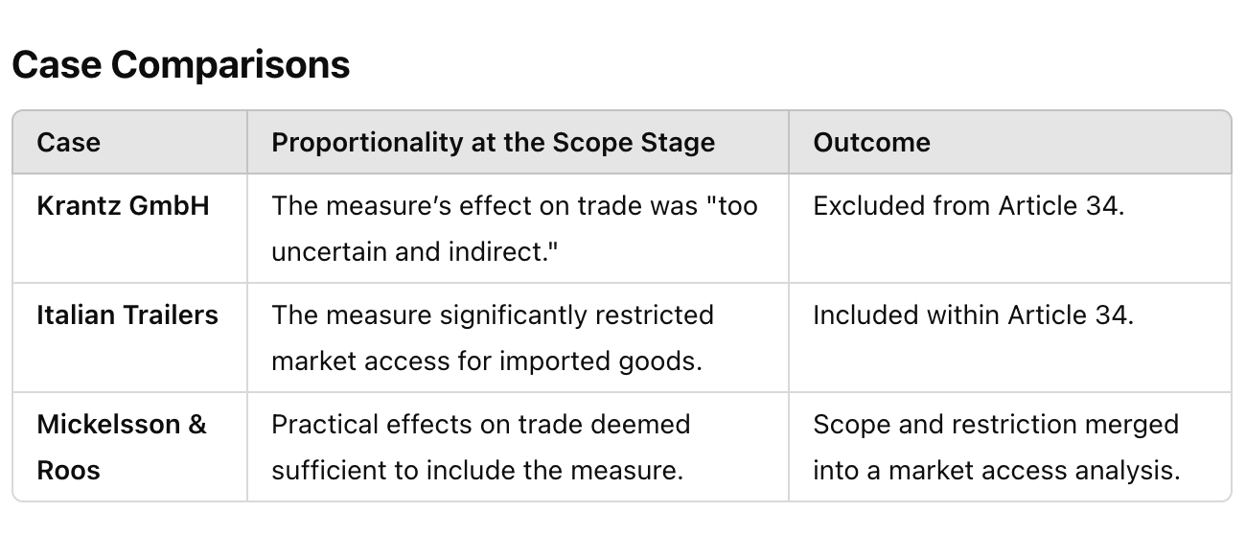

Recommendations for Reform
- Clarify the Threshold:
The CJEU should establish clear criteria for determining when a measure has sufficient trade effects to fall within the scope of Article 34.
- Separate Scope and Restriction:
Proportionality should be confined to justification stages, ensuring that the scope analysis remains a purely formal inquiry into cross-border trade.
Proportionality at the scope stage plays a limited but increasingly significant role in determining whether a measure falls within the ambit of EU free movement law. While it ensures flexibility by assessing the significance of trade effects, it also creates legal uncertainty and blurs the boundaries between the scope and restriction stages. Van Leeuwen critiques this development as part of the broader centralisation of proportionality in free movement law, calling for greater doctrinal clarity to preserve the traditional analytical framework.

2. The Consequences of the Centralisation of Proportionality

Impact on Member State Autonomy
- Proportionality’s centralisation limits Member States’ discretion in regulating their domestic markets, even in areas traditionally considered outside EU competence.
- Example: In PreussenElektra (Case C-379/98), the Court upheld a German renewable energy scheme as proportionate but set limits on how Member States could implement similar policies in the future.

Shift in Judicial Power
- Proportionality empowers the CJEU to act as the ultimate arbiter in free movement disputes, centralising decision-making at the EU level.
- This shift reduces the autonomy of national courts, which previously played a larger role in applying EU law within their jurisdictions.

Legal Uncertainty
- Case-by-Case Balancing:
  - The flexible nature of proportionality creates uncertainty for Member States and businesses, as outcomes depend heavily on the Court’s subjective balancing of interests.
- Erosion of Predictability:
  - By merging the distinct stages of free movement law into a proportionality-driven framework, the Court undermines the clarity and predictability provided by the traditional structure.

Critique of the CJEU’s Approach
- Weatherill’s Perspective:
  - Weatherill argues that proportionality’s overuse risks creating a "super-constitutional" framework, where the Court substitutes its judgment for that of national legislators.
  - Quote: “Proportionality becomes an invasive doctrine that destabilises the balance between integration and subsidiarity.”
- Spaventa’s Warning:
  - Spaventa highlights that the centralisation of proportionality could lead to judicial overreach, particularly in sensitive areas like public health or cultural policy.
  - Quote: “Proportionality must be applied with caution to avoid undermining the legitimacy of EU law.”

Proposals for Reform
- Restoring the Four-Pillar Framework:
  - Van Leeuwen suggests that the CJEU should return to the traditional step-by-step approach, where proportionality is confined to the justification stage.
  - This would ensure greater clarity and respect for Member State autonomy.
- Clarifying Proportionality’s Role:
  - The Court should establish clear criteria for applying proportionality, reducing legal uncertainty and enhancing predictability for businesses and governments.

Conclusion of Section IV
- The centralisation of proportionality has fundamentally reshaped free movement law, prioritising flexibility and effet utile over doctrinal coherence.
- While proportionality enables the CJEU to balance diverse interests in complex cases, its overuse undermines legal certainty, Member State autonomy, and the structural integrity of free movement law.
- Van Leeuwen argues that the Court must strike a balance between maintaining proportionality as a valuable tool and preserving the distinct analytical stages of free movement law.

V. Conclusion

Overview
- In the conclusion, Van Leeuwen synthesises the key arguments made throughout the article, focusing on how the centralisation of proportionality has transformed free movement law.
- He critiques this development for undermining the traditional four-pillar structure (scope, direct effect, restriction, justification), and argues that it has created doctrinal ambiguities and legal uncertainty.
- The article ends with a call for a rebalancing of the legal framework to restore clarity and coherence.

1. Summary of the Central Problem
- Proportionality’s Dominance:
  - Proportionality, originally confined to the justification stage, has become the dominant analytical tool in free movement law.
  - It now permeates all stages, including scope and restriction, effectively merging the distinct pillars into a single proportionality-driven framework.
- Impact on Doctrinal Coherence:
  - This centralisation has eroded the traditional step-by-step structure, where each stage had a distinct function.
  - For example, in PreussenElektra (Case C-379/98), the Court bypassed the restriction analysis and focused directly on proportionality to uphold Germany’s renewable energy policy.
- Blurred Boundaries:
  - The interaction between pillars—particularly restriction and justification—has led to inconsistent outcomes and overlapping tests.
  - Example: Scotch Whisky Association v Lord Advocate (Case C-333/14), where the Court used proportionality to justify minimum alcohol pricing without clearly delineating the restriction and justification stages.

2. Consequences of Proportionality’s Centralisation

1. Legal Uncertainty
- The dominance of proportionality creates unpredictability for Member States and businesses.
- Case-by-Case Balancing:
  - Proportionality requires the Court to balance economic integration against public interest on a case-by-case basis, leading to subjective and inconsistent outcomes.
  - Example: In Schmidberger (Case C-112/00), the Court upheld Austria’s decision to allow a roadblock protest based on proportionality, while in other cases, less intrusive measures have been struck down.

2. Member State Autonomy
- The broad application of proportionality allows the Court to scrutinise virtually all national measures, undermining the subsidiarity principle (Article 5(3) TEU).
- Judicial Overreach:
  - Van Leeuwen argues that the Court’s expansive use of proportionality reflects a shift towards judicial policymaking, reducing Member States’ discretion in areas such as public health, environmental protection, and cultural policy.
  - Example: In Omega Spielhallen (Case C-36/02), the Court upheld Germany’s ban on “laser tag” games as proportionate to the protection of human dignity, effectively prioritising EU law over national constitutional values.

3. Erosion of the Four-Pillar Framework
- The merging of the four pillars into a single proportionality analysis undermines the clarity and logic of free movement law.
- Loss of Distinct Roles:
  - Each pillar (scope, direct effect, restriction, justification) historically served a specific purpose, ensuring logical and predictable reasoning.
  - By focusing on proportionality, the Court risks ignoring the foundational principles that underpin the internal market.

3. Recommendations for Reform

Restoration of the Traditional Structure
- Van Leeuwen advocates for a return to the traditional four-pillar framework, with each stage playing a distinct role:
  - Scope: Clearly define the cross-border element required for EU law to apply.
  - Direct Effect: Maintain a clear distinction between vertical and horizontal direct effect, ensuring consistency in the application of free movement provisions.
  - Restriction: Focus on whether the measure constitutes a genuine obstacle to free movement, without conflating this analysis with justification.
  - Justification: Confine proportionality to the justification stage, assessing whether the restriction serves a legitimate public interest and is proportionate.

Clarification of Proportionality’s Role
- While proportionality remains a valuable tool, its use should be limited to the justification stage to prevent it from overshadowing other elements of free movement law.
- Clear Criteria for Proportionality:
  - The Court should establish objective criteria for applying proportionality, reducing the scope for judicial discretion and enhancing legal certainty.

4. Final Reflections

Balance Between Integration and Autonomy
- Van Leeuwen highlights the need to balance the EU’s objective of market integration with respect for Member State autonomy.
- Preserving Subsidiarity:
  - The subsidiarity principle must be reinforced to ensure that the EU does not overreach into areas of national competence.
- Proportionality as a Safeguard:
  - Proportionality should be applied as a safeguard against excessive restrictions on free movement, rather than as an all-encompassing analytical tool.

CJEU’s Role
- Van Leeuwen calls on the CJEU to exercise restraint in its use of proportionality, recognising the limits of its judicial role and respecting the diversity of national policies and values.

Key Takeaways
- Proportionality’s Strengths and Weaknesses:
  - While proportionality is essential for balancing competing interests, its centralisation undermines the coherence of free movement law.
- Need for Clarity and Predictability:
  - Restoring the traditional structure of free movement law would enhance legal certainty and ensure that national measures are assessed systematically.
- Judicial Responsibility:
  - The CJEU must strike a balance between ensuring the effectiveness of free movement provisions and respecting Member State autonomy.

Conclusion of Section V
- Van Leeuwen concludes that the centralisation of proportionality has fundamentally reshaped free movement law, creating flexibility at the cost of doctrinal coherence and legal certainty.
- He calls for a return to the traditional four-pillar framework, with proportionality confined to the justification stage, to restore balance and predictability to the legal system.
- Ultimately, Van Leeuwen emphasises the importance of preserving the balance between market integration and national sovereignty, ensuring that the EU’s internal market functions effectively without encroaching on Member State autonomy.

